**Practical No. 4B (Batch B4)**

**Installation of MPI and implementation of basic functions of MPI**

**Class:** Final Year (Computer Science and Engineering)

**Year:** 2021-22 **Semester:** 1 **Date**: 13/10/2021

**Course:** High Performance Computing Lab

**Exam Seat No:**

2018BTECS00007 – Shubham Ramdas Mali

Complete the installation of MPI on the platform chosen by you.

Q1: Implement a simple hello world program by setting number of processes equal to 15.

Screenshot 1:

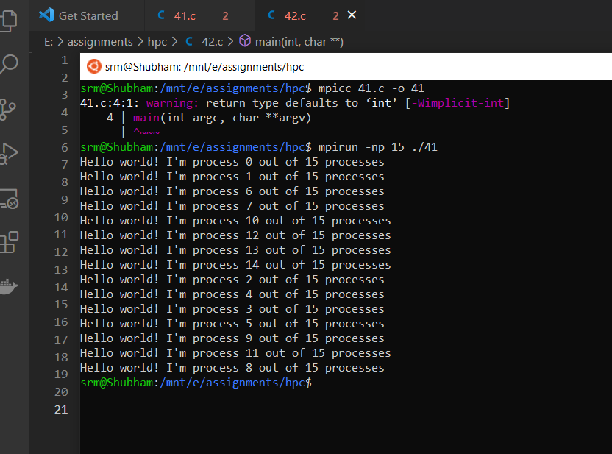

Information 1:

15 processors are executing to print hello world.

Q2. Implement a program to display rank and communicator group of ten processes.

Screenshot 2:

